FACTOR PLOT

Factor plot is a versatile plotting function in the seaborn library. It allows users to create various categorical plots for data visualization. With Factor plot, we can visualize relationships between variables across different categories.

seaborn.factorplot() method is used to draw a categorical plot onto a FacetGrid.

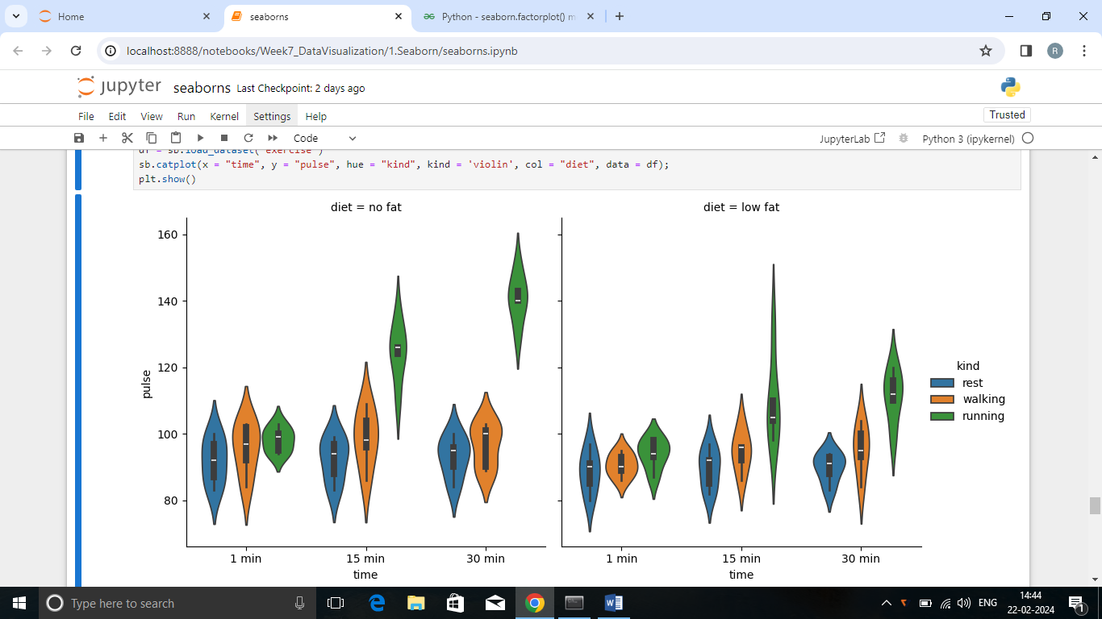

This plot provides a clear representation of human pulse rate with no and low fat while at rest, on walking and on running in a cdertain duration of time.

Here, the duration of exercise time is taken as x-axis and the pulse rate while exercising is taken as y-axis to conclude which category of exercise is good to have a normal heart rate at different diet condition.

* 60-100 per min is the normal pulse rate at rest
* 100-120 per min is the normal pulse rate while walking
* 100-160 per min is the normal pulse rate while running

**Summary**

Zero Fat per min

* Most of the humans pulse rate is between the range of 85-100 while at rest
* Most of the humans pulse rate is between the range of 90-110 while walking
* Most of the humans pulse rate is between the range of 95-110 while running

15 min

* Most of the humans pulse rate is between the range of 85-100 while at rest
* Most of the humans pulse rate is between the range of 95-105 while at rest
* Most of the humans pulse rate is between the range of 120-130 while at rest

30 min

* Most of the humans pulse rate is between the range of 90-95 while at rest
* Most of the humans pulse rate is between the range of 90-105 while at rest
* Most of the humans pulse rate is between the range of 140-145 while at rest

Low Fat per min

* Most of the humans pulse rate is between the range of 85-95 while at rest
* Most of the humans pulse rate is between the range of 90-95 while at rest
* Most of the humans pulse rate is between the range of 95-100 while at rest

15 min

* Most of the humans pulse rate is between the range of 85-95 while at rest
* Most of the humans pulse rate is between the range of 95-99 while at rest
* Most of the humans pulse rate is between the range of 105-110 while at rest

30 min

* Most of the humans pulse rate is between the range of 90-98 while at rest
* Most of the humans pulse rate is between the range of 95-100 while at rest
* Most of the humans pulse rate is between the range of 110-125 while at rest

From these above information, we can analyse that the person with zero fat heart rate is high than normal when compared with low fat person. They require more energy(oxygen & nutrients) to meet the demands of exercise.

Low fat category is also not good to maintain a normal pulse rate while exercising. Person with low fat heart rate is also near to 160 while running 15 minutes.

Only few person’s heart rate is low than normal while walking more than a minute.

“No **LOW** fat, No **ZERO** fat, Maintain **ESSENTIAL** fat”